https://phet.colorado.edu

Remote Learning with PhET Simulations
New PhET user?
Find the right sim
Provide students access
Scaffold your lesson
Maintain student inquiry
Show student thinking
Help students to test their knowledge
Find remote lessons
Use Java or Flash simulations
Access HTML5 prototypes

New PhET user?
Welcome to the PhET community! Review our Welcome Letter with tips and recommendations to get started with PhET sims.

Find the right sim
Refer to our topic alignment documents:
Physics sim alignment
Math sim alignment

Provide students access
Provide a direct link to the simulation URL in the lesson:
Direct sim link: https://phet.colorado.edu/sims/html/ph-scale/latest/ph-scale_en.html (RECOMMENDED)
Sim page link: https://phet.colorado.edu/en/simulation/ph-scale (NOT RECOMMENDED)
Embed the simulation:
In a webpage, using an iframe: copy-paste the embed code
In OneNote: paste the link (video tutorial)
In Canvas: use embed code (video tutorial)
In Moodle: multi-step (how to document)
In Edulastic/Fromative: use embed code (video tutorial)
In Google Classroom: click Google Icon on sim page
Offline access:
Download all or individual sims, or an offline version of the website at our Offline Access page

Scaffold your lesson
Limit students to a specific screen using “?screens=” (video tutorial)
Example full sim URL: https://phet.colorado.edu/sims/html/beers-law-lab/latest/beers-law-lab_en.html
Example sim URL with screen 2 only: https://phet.colorado.edu/sims/html/beers-law-lab/latest/beers-law-lab_en.html?screens=2
Use screenshots to help communicate specific set-ups.
Example:
Measuring Current | Measuring Voltage
“Current” is the flow of charge, measured in Amps (Coulombs/s). An ammeter measures the current past a single point in a circuit.  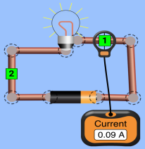  The current flowing through point 1 can be written as I1 = 0.09 A. | “Voltage” is a measure of the difference in electric potential between two points. The voltmeter measures this difference by placing the two leads at two different points.  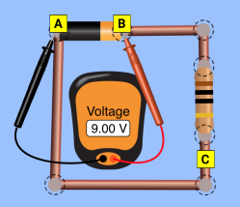  The voltage between points A and B can be written as VAB = 9 V.
Use table scaffolds for qualitative or quantitative data collection (but try to maintain student agency in sim use).
Example:
Action | Gravity Force
Put star and planet closer together | 𝥁 Increases 𝥁 Decreases
 | 𝥁 Increases 𝥁 Decreases
 | 𝥁 Increases 𝥁 Decreases
General teacher pedagogical resources and guides are available here.

Maintain student inquiry
Invite students to play with the sim before the lecture as an introduction to the topic.
Start with an “open explore” question.
Example:

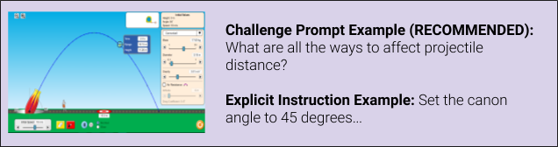
Use challenge prompts to engage students in STEM practices, rather than explicit instruction on how to use the simulation.
Example:

Include headers in your worksheets to help students to know what is expected in each part of the activity.
Example from Build an atom Remote Lab by Patricia Loeblein:

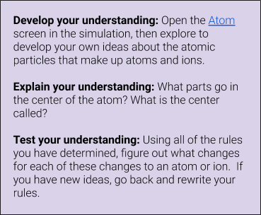

Show student thinking
Qualitative: Have students take screenshots of the sim (using their favorite snip tool) to use as forms of evidence and add supporting explanations to explain an idea.
Quantitative: Have students take data with the sim, make tables and graphs in Google Sheets (or similar), and paste screenshots of their work into their labs.

Help students to test their knowledge
Add some concept questions for students to apply the ideas at the end of the activity/lab.
Example:
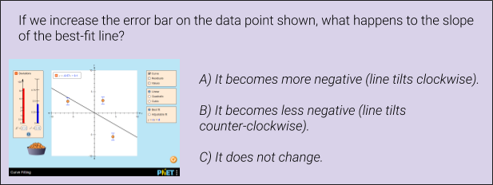
If the sim has a game: Have students play the game in the sim and take a screenshot of their completion/score.

Find remote lessons
Example Physics lab: Introduction to Circuits Remote Lab
Example Chemistry lab: Isotopes‌ ‌and‌ ‌Atomic‌ ‌Mass‌‌ ‌Remote Lab
Example Math lesson: Exploring Slope-Intercept Form of a Line
Browse all remote learning activities on the PhET website.
Note: You don’t need to request access to Google Docs. Simply download the document or make a copy to your drive. From there you can edit and share your document with students.

Use Java or Flash simulations
Since Java and Flash can sometimes be problematic for student computers (especially Chromebooks), teachers are encouraged to create mini screencast experiment videos to demonstrate a concept.
- Java and Flash sims will run on full computers (PhET System Requirements, MacOS troubleshooting, or Windows troubleshooting)
- Use Zoom (or another tech) to capture your screen as you run experiments with the sim.
- Post videos for students, and write your sim lesson/activity with links to these videos as opposed to the sim.

Java via CheerpJ
We are constantly working to port our Java simulations to HTML5. In the meantime, we are utilizing CheerpJ to allow Java sims to run in a browser. You can find all of these browser-compatible sims on our Java via CheerpJ page.

Access HTML5 prototypes

HTML5 prototypes are only available in English but will be made translatable once published to the PhET website.
(Caution: these simulations are not feature complete or fully tested, so you may find bugs or other issues.)

Thank you for being a part of our wonderful teacher community! If you write any lesson for remote learning, please share them with other teachers on the PhET website. If you have any questions, check out our help center, or contact phethelp@colorado.edu.

