

**Bottle A: top unit**

**Bottle E: deep funnel unit**

**Bottle B: internal unit**

**Cotton cord in soil goes through cap and into water**

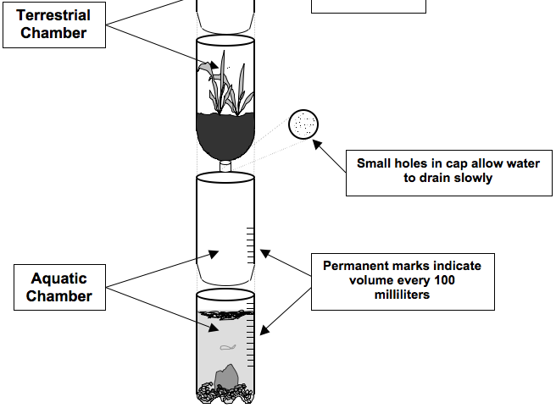

**Bottle A: deep base unit**