Colorimetric Determination of % Cu in Brass

The mass percentage of copper in brass can be determined by first reacting it with concentrated nitric acid, and then using a spectrophotometer to analyze the color intensity of the copper (II) nitrate solution that forms. A higher concentration of the colored solution absorbs more light (and transmits less) than a solution of lower concentration. The Vernier SpectroVis Plus monitors the light received by the photocell as either an absorbance or a percent transmittance value.
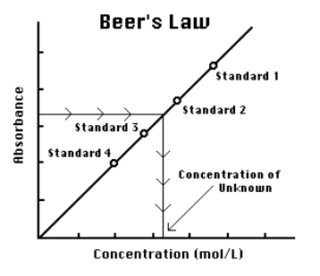
Figure 2
You are to prepare five copper (II) nitrate solutions of known concentration (standard solutions). Each is transferred to a small, rectangular cuvette that is placed into the SpectroVis. The amount of light that penetrates the solution and strikes the photocell is used to compute the absorbance of each solution. When a graph of absorbance vs. concentration is plotted for the standard solutions, a direct relationship should result, as shown in Figure 2. The direct relationship between absorbance and concentration for a solution is known as Beer’s law.
The concentration of an unknown Cu(NO₃)₂ solution is then determined by measuring its absorbance with the Colorimeter. By locating the absorbance of the unknown brass solution on the vertical axis of the graph, the corresponding concentration can be found on the horizontal axis (follow the arrows in Figure 2). The concentration of the unknown can also be found using the slope of the Beer’s law curve.

Problem: Can you determine the molarity of copper (II) nitrate solution made from the brass with a colorimeter, and use this data to determine the % by mass of copper in brass?

Procedure:
1. Determine the mass of two brass .22 caliber rifle shells to + 0.0001 g. Place the shells in a small beaker. Under the fume hood, add about 10 mL of 15.8 M HNO3(aq) and cover with a watch glass. After the metal dissolves completely, add 50 mL of distilled water to the beaker. Transfer the solution to a 100 mL volumetric flask. Rinse the beaker 3-4 times with 5 mL of distilled water and add the washings to the flask. Dilute to a final volume of 100.0 mL. The excess amount of nitric acid will dissolve the zinc and copper metals in the brass. Zinc nitrate solution is colorless, but the copper (II) nitrate has a deep blue color. The unbalanced ionic equation for the copper reaction is:
Cu(s) + NO3¹⁻(aq) → Cu²⁺(aq) + NO(g) in an acidic solution
2. Obtain 10.0 mL of 0.400 M Cu(NO3)2(aq) stock solution in a 10 mL graduated cylinder. Use a volumetric pipet to transfer 5.00 mL of this stock solution into a clean test tube and add 5.00 mL of distilled water. Thoroughly mix the solution. This makes 10.00 mL of 0.200 M Cu(NO3)2(aq). Repeat the dilution process to make 10.0 mL each of three more dilute solutions that are 0.100 M, 0.0500 M, and 0.0250 M.

- Set up the spectrophotometer and data-collection software.
  - Launch Spectral Analysis.
  - Connect the SpectroVis Plus Spectrophotometer to your Chromebook or computer.
  - Click or tap Absorbance vs. Wavelength.
- Calibrate the spectrophotometer.
  - Place the blank cuvette in the spectrophotometer.
  - Select Finish Calibration. Note: If necessary, wait for the spectrophotometer to warm up before selecting Finish Calibration.
- Measure the absorbance spectrum of the copper (II) nitrate solution.
  - Remove the blank cuvette from the spectrophotometer. Refill the cuvette with the copper (II) nitrate solution.
  - Start data collection. A full spectrum graph of the solution will be displayed. Stop data collection.
  - Repeat Parts a–b for the remaining five solutions containing iron or zinc ions that could be a component of the brass sample. Note: The previous data set is automatically stored when you collect another Run.
- To save the file, click or tap File, , and choose Save. Note: Do not close Spectral Analysis app; you will collect more data.
- Dispose of all solutions as directed by your instructor.
Measure the Absorbances of Standard Solutions of Cu(NO3)2
- Examine the graph of absorbance vs. wavelength for the 0.40 M solution of copper (II) nitrate from Part II of the Initial Investigation. Choose a wavelength that fits these three criteria: (1) the wavelength is 550–740 nm, (2) the absorbance is 0.70–1.00, and (3) none of the ionic species tested in Part II will interfere at the wavelength you choose. Values that fit these criteria provide a more accurate measure of the Cu(NO3)2 solutions.
- Select the optimal wavelength, and set up the-data collection mode.
  - Click or tap File, , and choose New Experiment.
  - Click or tap Absorbance vs. Concentration.
  - Fill a cuvette 3/4 full with the 0.40 M copper (II) nitrate solution and place the cuvette in the spectrophotometer.
  - The live graph will update with the spectrum of the sample. Click or tap the desired wavelength or enter the wavelength you found in Step 9 as the Wavelength. Click or tap Done.
- Collect absorbance-concentration data for the copper (II) nitrate standard solutions.
  - Start data collection.
  - Using the most dilute Cu(NO₃)₂(aq) standard solution, rinse the cuvette twice with ~1-mL amounts and then fill it 3/4 full. Wipe the outside with a tissue, place it in the Spectro-Vis, and close the lid. Read and record the Absorbance value. Discard the cuvette contents back into the original test tube.
  - Continue testing the other solutions, starting with the most dilute Cu(NO₃)₂ to the most concentrated (0.400M). Finally, determine the absorbance value of the unknown Cu(NO₃)₂ solution.
  - Using the absorbance and concentration values for the five standard solutions, prepare a graph of the absorbance(Y) versus the concentration(X) values. Draw a best-fit straight line for your data and calculate the slope and y-intercept for Beer’s plot. Then determine the concentration of your unknown brass solution based on its measured absorbance.
  - Calculate your % by mass of copper in the brass sample.
- To save the file, click or tap File, , and choose Save and enter a filename.
Calculations and Conclusions:

1. Show the calculations used to prepare the Cu(NO3)2(aq) with known molarities.
2. Label the data point for your unknown brass solution on the graph print out.
3. Based on the statistical analysis(slope and y-intercept values) of the best fitting straight line, calculate the molarity of the Cu(NO3)2(aq) found in 100.0 mL of the brass solution.
4. Determine the mass of Cu dissolved in the brass solution, and use this value to calculate the mass % of Cu in the brass sample.
5. Enter your data into the class spreadsheet for group data analysis.
Sample Data:

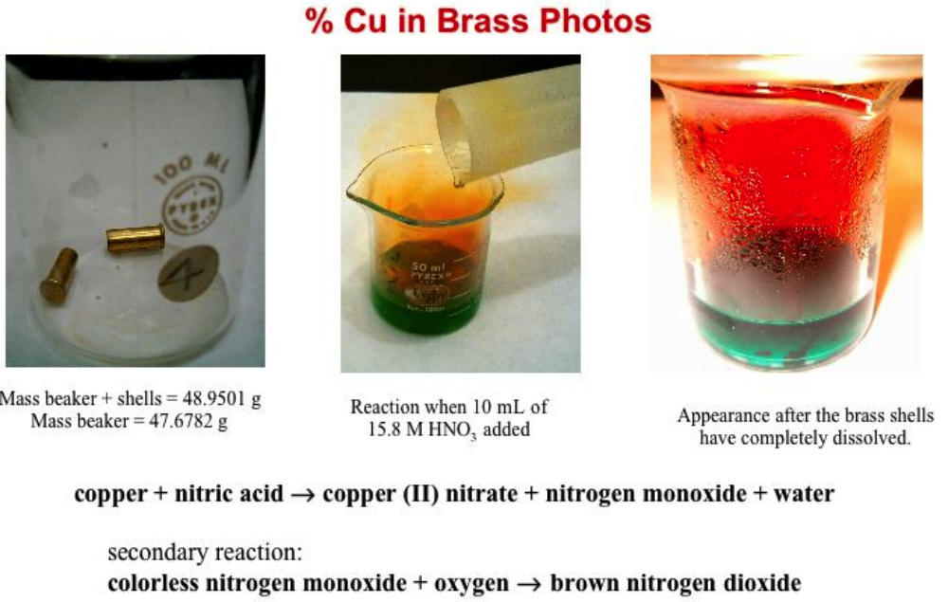

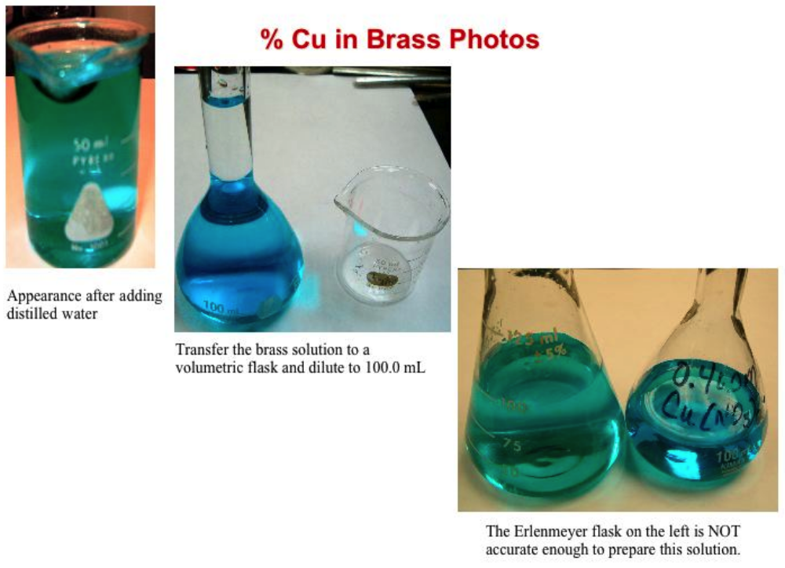
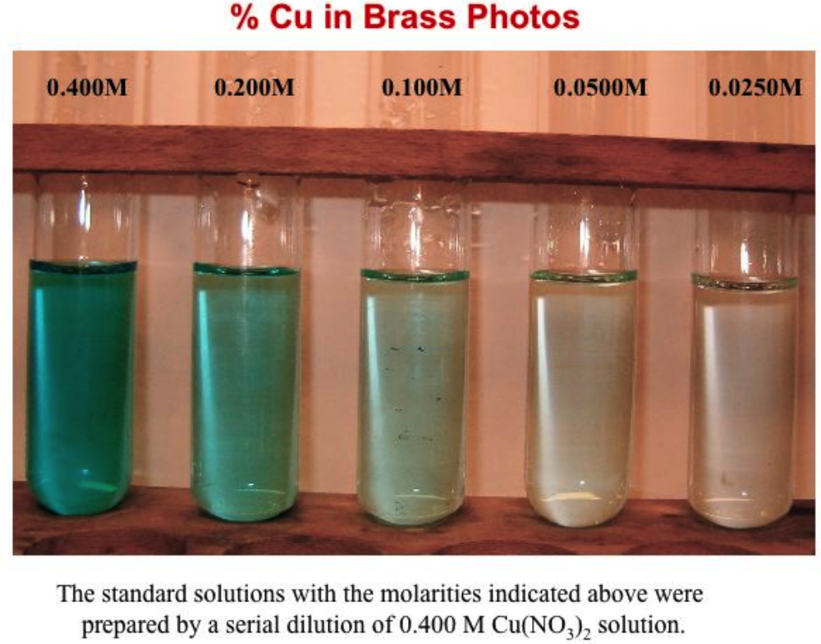

Beer’s Law Plot created with Vernier Graphical Analysis App

Calculations: Show your work!

