Chromatography Lab: Putting Intermolecular Forces to Work

Background: Chromatography is a technique used to separate a mixture into its various colored components based on differences in the degree of attractive forces. The mixture is carried by the mobile phase (some type of solvent) across a stationary phase, such as porous paper, and the components stop moving at a point where the attractive forces for the stationary phase becomes greater than the attractive forces for the mobile phase. In this lab, you will use several chromatography methods to separate various mixtures.
Paper chromatography - this type of chromatography uses porous paper as the stationary phase which absorbs some type of liquid solvent as the mobile phase. Polar versus nonpolar solvents will result in different degrees of solubility, depending on the nature of the mixture being separated.
Problem: A crazed-chemistry student has written a letter demanding an A on this year’s final report card, or else! After rounding up the usual suspects, their pens were confiscated so that an analysis of the letter could be performed and the culprit identified. Your job is to perform that analysis. A chromatograph of the actual writing on the letter was conducted by your teacher for comparison.

1. First, take a small sample of the writing and cut the paper into four sections. Place 5 drops of water on the writing in the center of one of the sections. Repeat this with the other three sections, using ethanol, acetone, and hexane in place of the water. Which solvent works best in separating/dissolving the colors of the pen? Use this solvent (or a mix of several that dissolved the ink) for the following separations.
2. Obtain a 10 cm x 20 cm piece of porous chromatography paper. Draw a pencil line across the long side of the paper about 1 cm from the edge. Make pencil dots on the line at equal distances apart and label them with the numbers 1 to 6. Use each of the six suspects’ pens to make a large dot at the appropriate spot on the line.
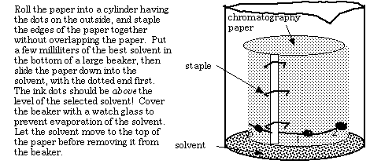

- Compare your results from the known pens to the chromatograph from the pen used to write the actual letter to determine which one was used to write the note. This can be done qualitatively by noting how many different colored spots separated from the pen mark and approximately how far they traveled up the paper. Quantitatively, the retention factor, R_{f} value, can be determined for each dye spot by dividing the distance from the center of the spot to its starting point by the distance the solvent traveled. If there are multiple dye spots from a single pen, then a separate calculated R_{f} value should be determined for each colored spot. Identify the suspect and justify your answer!

